UCSF Chimera - I - Introduction

Jean-Yves Sgro

October 10, 2017

Table of Contents

1 Introduction 2

2 Set-up 3

3 Preliminary notes: 3

4 Chimera Basics 4

4.1 Learning objectives for "Chimera Basics" 4

4.2 Launching Chimera 4

4.3 Identifying amino acids 6

4.4 Mouse rotations 6

4.5 Presets 7

4.6 Save an Image 8

4.7 Save session 9

4.8 Closing & quitting 9

5 Chimera Menus 9

5.1 Learning objectives for "Chimera Menus" 9

5.2 Open molecule 10

5.3 Molecule structure information 10

5.4 Select and Actions menus 12

5.5 Select and color 15

5.6 Focus 16

5.7 Selection by mouse clicking 16

5.8 Adding a label 17

5.9 Selecting by sequence 18

6 Structure Analysis 19

6.1 Learning Objectives for "Structure Analysis" 19

6.2 Open 3D structure 19

6.3 Tools menu highlights 19

6.4 Structure analysis 22

7 Surface and electrostatics 25

7.1 Learning objectives 25

7.2 Show molecular surface 25

7.3 Display Coulombic surface coloring (electrostatics) 26

8 Structure Comparisons 28

8.1 Learning objectives 28

8.2 Open hemoglobin structure and color by chain 28

8.3 Open myoglobin structure and 3D-align 29

9 Favorites 34

10 Preferences 34

10.1 Font size 34

11 Acknowledgments 35

12 REFERENCES 35

# Introduction

We will use [UCSF Chimera](http://www.cgl.ucsf.edu/chimera) (Pettersen et al. 2004) for molecular graphics visualization, but the software is capable of many complex operations (see also *Acknowledgments* below.)

The material presented here is inspired by the RCSB Protein Data Bank *YouTube*[1] tutorial series provided as a list[2] created by Dr Shuchismita Dutta, Ph.D.

Chimera is free for academic use and is available for download at <https://www.cgl.ucsf.edu/chimera/download.html> but is already installed on the iMacs under the Macintosh OS.

# Set-up

If you are using the iMac for the first time you may need to review and update the mouse button assignment by going to the "Apple" menu at the top left:

**Apple > System Preferences... > Mouse**

"Standard" setting should be set as (if you are right-handed) :

* Left: Primary Button
* Wheel: Button 3
* Right: Secondary button

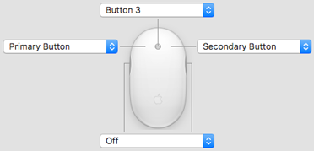

"**Verify mouse settings in System Preferences.**"

*Note*: If you are left-handed inverting Left and Right assignment might be best for you.

**TASK**

This button will invite you to act on **suggested actions**.

# Preliminary notes:

* Most actions in Chimera can be accomplished both with mouse actions and menus but also by line-command. We will start with mouse methods which are easier to grasp and slowly move to command-lines time permitting.
* Chimera menus or tools often open a new, separate window to use the tool and therefore it may be challenging a times to handle all open windows.

# Chimera Basics

## Learning objectives for "Chimera Basics"

* Launching Chimera
* Open a 3D coodinate file from RCSB Protein Data Bank
* Move & interact with displayed molecule
* Review "preset" views
* Save and image; save a session
* Close and quit

Example file: [1mbo](http://www.rcsb.org/pdb/explore/explore.do?structureId=1MBO). *Structure and refinement of oxymyoglobin at 1.6 angstroms resolution* (Phillips 1980).

## Launching Chimera

### Finding Chimera

On a Macintosh Chimera is installed in /Applications.

You can also find Chimera by using Spotlight Search: the "magnifying glass" icon on the top right of the Mac.

On a Windows computer you would type Chimera in the search area next to the **Start** button in Windows 7, or within a "magnifying glass" text entry, also bottom left, with "Cortna" helper in Windows 10.

### Launching

Double click on the Chimera icon.

For the very first launch, Chimera will open a black window with a menu bar at the top. (*Note that on a Macintosh these menus are also found on the Finder menu bar at the very top of the computer screen.*)

After this first time, new launches will show a blue screen with a history list of previously opened structures shown on the right hand side. You can click on any of these to reopen the structures in a new session.

### Open a 3D structure

The **File** menu offers 2 ways to load a structure:

1. **File > Open...** that is already saved on your computer
2. **Fetch by ID...** to *fetch* by an identifier. In that case the computer must be connected to the Internet.

In both cases you would need to know the PDB ID code of four characters gleaned *e.g.* from the PDB site or a publication.

When the structure is loaded, it is presented in a default preset mode showing ribbons and select atoms as stick representation.

**TASK**

**Fetch PDB id 1mbo**:

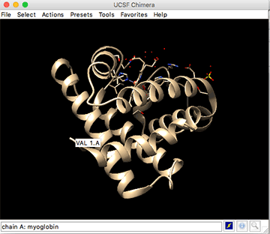

"**Structure 1mbo opens as ribbons; ligands as sticks. Hovering the mouse over will reveal amino acid info.**"

Note that the 1mbo protein structure is shown as a ribbon, while the ligands and some specific amino acids are shown as stick models in this default preset.

Later we will review this default presentation mode with the "Presets" options.

*Note*: When using Fetch Chimera will save the downloaded file within the user's Downloads/Chimera directory. In this case the file will be saved as 1MBO.pdb and can be explored with a simple word processor as it is a "plain text" file. On a Mac one would use the built-in text editor TextEdit and on Windows WordPad or perhaps NotePad.

## Identifying amino acids

Hovering the mouse over a depiction will reveal the residue name and the name of the chain pointed out by the mouse.

**TASK**

**Hover the mouse over at N-t** to reveal info.

For example, if you place the mouse over the N-terminus and stop moving a temporary label within a box will reveal: VAL 1.A which means: chain A, residue 1 which is a valine. (See above illustration.)

Later we will learn how to select and label an amino acid.

## Mouse rotations

An external, 3-button mouse is best to interact with the displayed molecule.

* **Left button**: ***Rotation***. Click close to the molecule and rotate around the x and y axes.
* The same movement when performed far from the molecule, e.g. far on the left side, will rotate the molecule around the z axis.
* **Right button**: ***Zoom***. Press the right button to zoom in (left-to-right or top-to-bottom) and out (right-to-left or bottom-to-top)
* **Center wheel**: ***Translation***. (or zoom)
  + click-and-hold the wheel for translating the molecule
  + scrolling the wheel will be as the zoom effect.

*Note*: if these button do not appear to work as planned, review the mouse preference settings as described above.

## Presets

Once you have found a suitable view, you can try the "**Presets**" menus that alter the display of the molecule with preset options.

The first one ** Presets > Interactive1(ribbon)** looks very similar to the current display when a molecule is opened.

The difference is that the ribbon is rainbow-colored from a blue-colored N-termial blue to a red-colored C-terminus.

**TASK**

**Engage the Presets menus to explore the preset representations that are offered.**

|  |  |  |
| --- | --- | --- |
| Presets menus | check if seen | Notes |
| Interactive 1 (ribbons) | [ ] | ribbon is rainbow colored |
| Interactive 2 (all atoms) | [ ] | protein is wireframe, ligands are spheres |
| Interactive 3 (hydrophobicity surface) | [ ] | blue: hydrophilic; orange: hydrophobic |
|  |  |  |
| Publication 1 (silhouette, rounded ribbon) | [ ] |  |
| Publication 2 (silhouette, licorice) | [ ] |  |
| Publication 3 (depth-cued, rounded ribbon) | [ ] |  |
| Publication 4 (depth-cued, licorice) | [ ] |  |

*Note*: the **Interactive** menu options create a view. The **Publication** menus alter the view prepared by the **Interactive** menu. Background is white.

## Save an Image

To save an image, use the menu cascade: **File > Save Image...**

* File name: Provide a name for the file; if needed navigate to where the file will be saved.
* File type: default format is PNG, alter format if desired from this pull-down menu.
* Image width: and Image height: image size is same as current Chimera display by default; alter if needed with these menues.
* Click Save

Note other options such as Transparent background button etc.

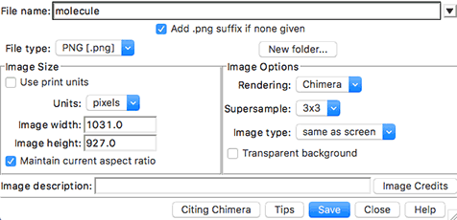

"**Save image window.**"

**TASK**

**Save a test image on the Desktop**

## Save session

A session file contains most of the information to recreate the current state of the Chimera display. It retains selections and molecules currently uploaded within Chimera.

To save a session use the menu cascade: **File > Save Session As...**

A session file can be reopened with the menu option: **File > Restore Session...**

**TASK**

**Save the current state of Chimera in a session file on the Desktop**

## Closing & quitting

When you are done with a session you can use the menu **File > Close Session** to close the session an keep Chimera running and open and start a new session.

**TASK**

**Close this session**

If you are finished, you can can use **File > Quit** to exit Chimera gracefully and return to your computer.

# Chimera Menus

## Learning objectives for "Chimera Menus"

* Review functions in the Menus
* Select: residues, chains, atoms, etc.
* Actions: display and alter representations; color and label.

Example file: [2hhb](http://www.rcsb.org/pdb/explore.do?structureId=2hhb). *The crystal structure of human deoxyhaemoglobin at 1.74 A resolution* (Fermi et al. 1984).

## Open molecule

**TASK**

**Open or Fetch PDB ID 2hhb**

This will open the preset "first view" display, with most of the protein shown as ribbon and the heme and close amino acids as stick representation to highlight interaction between the residues and the heme group.

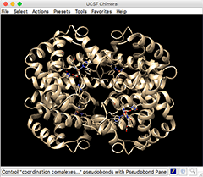

"**Structure 2hhb opens as ribbons; ligands as sticks**"

This structure contains 4 chains that are for now all colored the same. In a following section we will learn how to select and color chains.

## Molecule structure information

### Chains

The structure 2HHB contains 4 chains:

* 2 alpha chains labeled A and C and
* 2 beta chains labeled B and D.

This information can be gleaned from the PDB web page for [2hhb](http://www.rcsb.org/pdb/explore.do?structureId=2hhb) scrolloing down, or from the text header of the PDB file saved in the user's downloads folder as 2HHB.pdb:

COMPND MOL_ID: 1;  
COMPND 2 MOLECULE: HEMOGLOBIN (DEOXY) (ALPHA CHAIN);  
COMPND 3 CHAIN: A, C;  
COMPND 4 MOL_ID: 2;  
COMPND 5 MOLECULE: HEMOGLOBIN (DEOXY) (BETA CHAIN);  
COMPND 6 CHAIN: B, D

### Amino acids

Amino acids are reported within the SEQRES entry in the header as the 3-letter code sequence of the proteins starting at line 529:

529 SEQRES 1 A 141 VAL LEU SER PRO ALA ASP LYS THR ASN VAL LYS ALA ALA  
 530 SEQRES 2 A 141 TRP GLY LYS VAL GLY ALA HIS ALA GLY GLU TYR GLY ALA

The 3D coordinates of the atomic structure of amino acids are reported further in the file

### Secondary structure

The header also contains information about the secondary structure from with the HELIX description as there are no beta sheets (SHEET) in the structure.

### Ligands

In addition there are also non-protein compounds such as the heme and a phospate ion which are reported at the bottom of the web page:

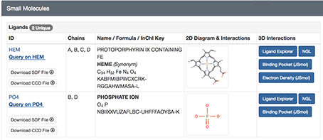

"**Lignands are reported and shown on web page**"

but also within the PDB header although one has to scroll down further to line 581:

581 HETNAM PO4 PHOSPHATE ION  
 582 HETNAM HEM PROTOPORPHYRIN IX CONTAINING FE  
 583 HETSYN HEM HEME

*Note*: all of the information on the file is ***parsed*** by Chimera and passed onto appropriate sections of the Select menu for specific selection as detailed below.

## Select and Actions menus

The Select menu offers various methods of selection: Chain, Chemistry, Residue, structure.

The some data ***parsed*** at the reading of the file will be passed on the menu, most notably that of the Chain option.

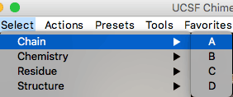

"**Chain info is parsed from PDB file and shown in menu Select > Chain**"

Selecting any item will display a **green halo** around the selected area for an easy visual of what is selected and indicating that it is ready to receive Actions commands.

**TASK**

**Select chain A** and test the menu options:

* **Actions > Ribbon > hide**
* **Actions > Ribbon > show**

Then alter the atoms & bonds currently displayed for chain A with the menus:

* **Actions > Atoms/Bonds > ball & stick**
* **Actions > Atoms/Bonds > sphere**
* **Actions > Atoms/Bonds > wire**

Note that not all atoms are shown or altered, only those that are currently displayed. Choosing **Actions > Atoms/Bonds > show** would show all atoms, and the specific selection of visible atoms (created by the "First view") would be lost.

### Selection "tricks"

**TASK**

**Try these selections**

* **Clear** any selection with **Select > Clear Selection**
* *a short-cut is to press the Ctrl key on the keyboard and click anywhere on the display background*.
* Select chain A again
* **Invert** selection: if chain A was selected now everything else except A is selected.
* Invert back to return to original selection

### Selection modes

#### replace and append

The default mode of selection is the **replace** mode that removes any previous selection and replaces it with a new selection. The current mode is reminded within the menu with parentheses.

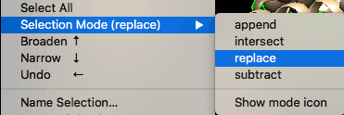

"**Default selection is replace.**"

**TASK**

**Try these selections**

* Select chain A (if it was not selected)
* Now select chain B and note that chain A is now dropped out of selection.
* Change selection mode to append
* Select chain A and note that both chains A and B are now selected
* Unselect everything (*e.g.* Ctrl-click on background)

#### intersect

The intersect mode would correspond to the boolean logical and that satisfies all conditions. The example/exercise below will let you select the heme but only that of chain B.

**TASK**

**Select heme of chain B by menu**

* Select by residue name: **Select > Residue > HEM** and note that all hemes are selected for all 4 chains.
* Change selection mode to intersect
* Select chain B and note that only the heme of chain B is now selected
* Reset the selection to replace
* Clear selection before continuing

## Select and color

In this section we will select chain A and color it red.

We will also explore the various options on how to apply the color.

**TASK**

**Select chain A and open color options**

* **Select > Chain > A**
* **Actions > color > all options** - go the very bottom of the menu to find this option.

|  |  |
| --- | --- |
| **Color Actions** |  |
| "Default selection is replace." | Note the "all of the above" button that applies to color to all of the above list. Using the buttons on top would allow coloring of specific depictions without changing the others. |

* Click on the red color to color everything red.

Now we will change only the color of the ribbon depiction:

* Click on the 'ribbons' button within the Color Actions window
* Click on yellow and the ribbon will turn yellow while the atoms represented as stick or spheres will remain red.

## Focus

A useful menu item is **Actions > Focus** as it will automatically zoom to the area that is selected to bring it closer within the 3D viewing area.

**TASK**

**Focus on chain A**

* Chain A should be still selected form the previous coloring exercise
* Use the menu **Actions > Focus** to zoom on this area.

## Selection by mouse clicking

One way to select a specific amino acid is to use the Ctrl-click method and then extending the selection with the keyboard arrow keys.

If you have followed from the previous exercises your display should show chain A colored as a yellow ribbon with specific red stick amino acids and focused closely to chain A.

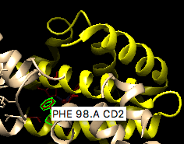

"**Amino acid PHE 98.A should be easy to spot**"

Amino acid PHE 98.A should be easy to spot within the chain A display and shown as stick and we will select it.

Note that in the illustration we now see the exact atom name (CD2 - carbon delta 2) that was *parsed* from the PDB file data.

**TASK**

**Select amino acid PHE 98.A**

* Ctrl-Click on any bond of PHE 98 - this will select this bond and perhaps also a portion of the ribbon.
* Extend the selection to the complete amino acid by pressing the Up arrow key on the keyboard.

*Notes about mouse selection*:  
- you can continue to augment the selection by pressing the Up arrow key multiple times, or the Down arrow key to go backwards.  
- The Right arrow inverts the selection and the Left arrow reverses this.  
- To select multiple atoms use Shift-Ctrl-Click - To select a rectangular region, press Ctrl and drag the mouse in the display.

## Adding a label

We will now follow the menu items to add a label to one of the amino acids.

To add the label do the following: **Action > Residue > Label > name**

To change the color of the label:

* **Action > color > all options...**
* click button residue labels
* click color of choice, *e.g.* white.

|  |  |
| --- | --- |
| "Amino acid PHE 98.A labeled" | The font size and shape is controlled by a preference setting that will be reviewed later.In this image the font size was increased to 36 from the default value of 16. |

## Selecting by sequence

It is possible to also select by protein sequence displayed with the menu cascade:

**TASK**

**Show sequence for protein chain A**

**Tools > Sequence > `Sequence**

and in the resulting window "Show Model Sequence" choose the sequence from the desired protein chain, for example click on **2hhb (#0) chain A** and click the **show** button.

If you "hover" the mouse on an amino acid, it's number is echoed at the bottom line of the window.

To select, even a single amino acid residue: **Click and Drag** the mouse onto the sequence letter(s) to be selected. They will become highlighted in green, and, within the 3D disply, the corresponding residues will be shown with the green halo of selection.

For example select "PHE 98" of chain A in the window: **Click and Drag** on the F on the middle line.

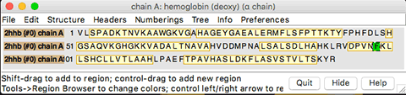

"**Drag and Click on F on middle line to select PHE 98.A**"

*Note*: clicking on any "light yellow" colored section without dragging will select all of the amino acids in that category: alpha-helical secondary structure.

Click the **Quit** button to close the sequence window.

# Structure Analysis

## Learning Objectives for "Structure Analysis"

* Explore **Tools** menu:
  + general controls, viewing controls, depictions and structure analysis
* Explore interations stabilizing a residue or ligand
* Measure distances between 2 atoms

Example file seen previously: myoglobin structure [1mbo](http://www.rcsb.org/pdb/explore/explore.do?structureId=1MBO).

## Open 3D structure

If you are continuing from the previous section you can simply close the session and re-open the previous session with 1mbo by clicking on the right hand panel on 1mbo [PDB].

## Tools menu highlights

*Note*: the Favorites menu can also be used to select some of the explored menu items.

### Viewing controls

#### Side View

**TASK**

**Open the Viewing panel**

Use the menu cascade: **Tools > Viewing Controls > Side View**

This control panel opens on the Side View mode, but please note that there are other tabs that we will explore.

**Available actions:**

* slab front view: may cut molecule from the front view
* slab back view: may cut the molecule from the back.

The name of the 2 vertical lines are:

* hither - for the line in the front
* yonder - for the line in the back

**TASK**

**Slab protein view with vertical yellow slab bars**

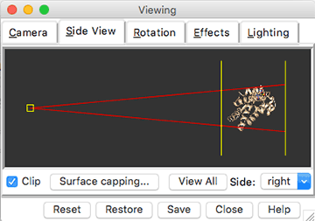

"**Use the vertical yellow lines to slab the protein view.**"

#### Effects

The Effects Tab has multiple options. The most dramatic in its effect is perhaps the silhouettes option that allows to draw a thick, black contour line around the cartoon, sphere or surface displays on the 3D panel.

**TASK**

**Explore "silhouette" options**

For example:

* click on the silhouettes button and observe the 3D display
* change the width from a default (likely 2.0) to *e.g.* 4.0 or a greater number.

#### Lighting

If you go on the Lighting Tab, you can see the obvious ways to change the lighting and the direction of the light shining on the molecule.

One of the most dramatic view method, in combination with the silhouette above is to change the mode: from two-point to ambient which in effect removes the shininess of the display. This creates a very "cartoonish" view mode with the silhouette highlights.

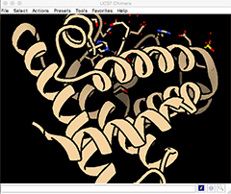

"**Cartoonish view with Effects,silhouette: 8.0 and Lighting, mode: ambient.** "

### Depiction

The **Tools > Depiction** menu options allows you to color the molecule in specific ways, for example by secondary structure, the first option in the list: Color Secondary Structure. Then click Apply within the window that opens.

Note that the myoglobin structure does not contain beta-sheets.

Another option is the rainbow color scheme, which was also created withthe first Presets menu (see above.)

For this view follow the menu cascade: **Tools > Depiction > Rainbow** click Apply within the window that opens.

## Structure analysis

### Residues 5 Å from heme group

The current view of the protein should be similar to the first Presets menu version with the protein shown as ribbon (perhaps rainbow colored) and the heme and amino acids close to the heme shown as stick models.

In the following exercise we will learn to select the amino acids that are shown as stick by distance criterion and alter their color.

**TASK**

**In this exercise we will select amino acid residues found within 5 Å of the heme group.**

* **Select > Residue > HEM** to select the heme group.
* **Select > Zone...** to select atoms that are within 5 Å of the heme group

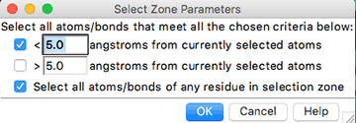

"**Zone selection panel.** "

* Note that if the bottom button is selected, if any one atom is selected with the distance criterion then all of the atoms of the amino acid residue that it is part of will also be selected, therefore selecting whole amino acids in the process.
* **Action > Color > by element** to alter the color of the stick representations

### Measuring distances

In this exercise we will measure the distance between the iron in the heme group and the coordinating histidine. We will select the specific atoms with the mouse.

**TASK**

**Measure the distance between FE in heme group and his 93.A.**

* Orient the molecule and zoom on the heme area. (*e.g.* select the heme and use **Action > Focus**, or rotate with left button and zoom with right button drag.)
* Select the 2 atoms to measure distance by holding the keyboard keys Ctrl+Shift and then left-button click to select and add to the selection. The heme iron should appear as an orange sphere and the closest atom of histidine 93 as stick.

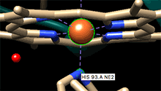

"**Ctrl+Shift to select heme FE and HIS 93.A NE2.**"

* Once the atoms are selected open the Struture Measurements panel: **Tools > Structure Analysis > Distances** and click the Create button.

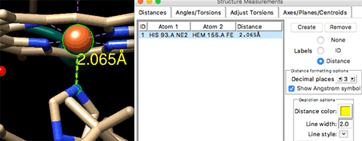

"**Create and alter distance measurement line and label.**"

* Note that the line thickness (width) and line style, and the label color and decimal places can easily be changed within panel. However, the font size is changed elsewhere to be reviewed later.

### Hydrogen bonds

In this exercise we will explore how to show hydrogen bonds and using selection methods to show them only for specific residues, in our example on the hydroxyl of Serine 92 (SER 92.A OC.)

The first step is to find ***all*** hydrogen bonds with the defaults options.

**TASK**

**Select hydrogen bonds.**

* **Tools > Structure Analysis > FindHBond** to find all hydrogen bonds in the structure using default parameters already selected.
* Click the Apply button at the bottom to reveal all H-bonds that can be displayed: within the helices, displayed side-chains and water molecules.

We will now display only specific H bonds for a residue of interest, and as an example it will be the hydroxyl of Serine 92. In order to do that, we will use a menu within the H-Bond Parameters panel:

* Ctrl-Click on the hydroxyl group of Serine 92 (it should be displayed as stick)
* Click on the button: Only find H-bonds with at least one end selected located in the middle of the H-Bond Parameters panel.
* Click the Apply button: now only the relevant H-bonds are shown.

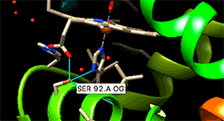

"**Create and alter distance measurement line and label.**"

# Surface and electrostatics

## Learning objectives

* Create a molecular surface
* Color by electrostatic potential (Coulombic)

## Show molecular surface

**TASK**

**Show molecular surface.**

* **Actions > Surface > Show** will display a molecular surface.

The color may be a default color (*e.g.* beige) or might be a rainbow color depending on the state of your molecule when you activate the menu.

*Note:* An alternate way to bring about a surface, colored by hydrophobicity by default is the preset setting obtained with the menu cascade:

* **Presets > Interactive 3 (hydrophobicity surface)**

## Display Coulombic surface coloring (electrostatics)

Exerpt from the Chimera web page on Coulombic Surface Coloring[3]

Coulombic Surface Coloring calculates electrostatic potential according to Coulomb's law:

$$Φ=Σ[q_{i}/ϵd_{i}]$$

$Φ$ is the potential (which varies in space), $q$ are the atomic partial charges, $d$ are the distances from the atoms, and $ϵ$ is the dielectric, representing screening by the medium or solvent. A distance-dependent dielectric ( $ϵ=Cd$ where $C$ is some constant) is sometimes used to approximate screening by implicit solvent.

*Note:* Poisson-Boltzmann calculations are more complex and, *if done correctly*, more accurate than simple Coulomb's law approaches. However, a Coulombic potential may suffice for visualization. Software that calculate a Poisson-Boltzmann grid are not included in Chimera.However, Chimera does include interfaces to such programs: [DelPhiController](https://www.cgl.ucsf.edu/chimera/docs/ContributedSoftware/delphicontroller/delphicontroller.html) requires a local (user-installed) copy of [DelPhi](http://compbio.clemson.edu/delphi), and the [APBS tool](https://www.cgl.ucsf.edu/chimera/docs/ContributedSoftware/apbs/apbs.html) can use either a web service or a locally installed copy of [APBS](http://www.poissonboltzmann.org/apbs/) (Adaptive Poisson-Boltzmann Solver).

**TASK**

**Coulombic Surface Coloring.**

* **Tools > Surface/Binding Analysis > Coulombic Surface Coloring** will open a window meant to color surfaces. The she top part of the window will list the surface(s) currently available within Chimera.
* Click Apply button o create an approximate electrostatic Colombic surface coloring. Keep the default values as well as the default suggested 3-colors of red, white and blue.

|  |  |
| --- | --- |
| Coulombic Surface Coloring | Notes |
| "Control window" | *Note 1*: to draw a scale click the button at the very bottom Create corresponding color key and use the mouse to draw at the desired size. Use the button Reverse ordering of above if necessary. *Note 2*: You can optionally use the Viewing panel (side view) to alter the image as we have seen in a previous section to add a silhouette contour or change the lighting option *e.g.* to "ambient." |

.

|  |  |
| --- | --- |
| Colored surface "2-lights" | Colored surface "ambient" |
| "Control window" | "Control window" |

# Structure Comparisons

## Learning objectives

* Compare the structures of two related proteins/domains
* Visualize the superposed structures of these proteins/domains.

Example files: myoglobin [1mbo](http://www.rcsb.org/pdb/explore/explore.do?structureId=1MBO) and hemoglogobin [2hhb](http://www.rcsb.org/pdb/explore.do?structureId=2hhb) both used in previous sections.

## Open hemoglobin structure and color by chain

**TASK**

**Open hemoglobin structure 2hhb.**

* Open the [2hhb](http://www.rcsb.org/pdb/explore.do?structureId=2hhb) structure.
* Color by chain: **Tools > Depiction > Rainbow**
* Select (click) the option chain in the Rainbow control panel
* Click the Apply button
* Click the Close button

Chains will be colored one solid color per chain as shown within the Color range options on the left side of the Rainbow control panel (see image.)

* Chain A: blue
* Chain B: cyan
* Chain C: yellow
* Chain D: red

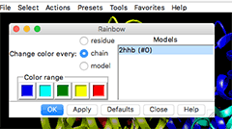

"**Choose chain within the Rainbow control panel.**"

## Open myoglobin structure and 3D-align

**TASK**

**Fetch myoglobin structure 1mbo and superimpose to a hemoglobin chain.**

* Use the **File > Fetch** menu to add the structure **1mbo** to the display. It will appear partly overlapping the hemoglobin structure.

We will now superimpose the myoblogin structure to one of the hemoglobin chain. For now we use default parameters

* **Tools > Structure Comparison > MatchMaker** to open the MatchMaker control panel.
* Click to select:
  + Reference strucure2hhb (#0) and
  + Structure(s) to match: 1mbo (#1)
* Click OK

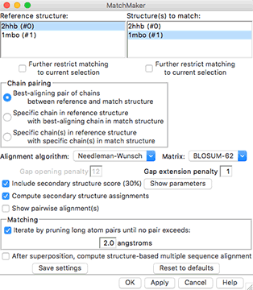

"**Select reference and matched structures in the MatchMaker control panel.**"

The 1mbo myoglobin structure will be be moved to overlap chain D of the hemoglobin structure.

*Note*: it is possible to select the exact chain to match by changing the option to: Specific chain(s) in reference structure with specific chain(s) in match structure which is the 3rd button within the Chain pairing box within the panel.

**TASK**

**Hide unmatched chains.**

Here we will select unmatched chains and hide them:

* **Select > Selection mode > append** to select multiple chains easily
* Select one by chains A, B, C of the hemoglobin structure.
* hide them: this will require 2 steps
* **Actions > Ribbon > hide**
* **Actions > Atoms/Bonds > hide**
* **Select > Selection mode > replace** to return selection to replace

Note that for chain A, there is now a choice between the 2hhb an 1mbo structures.

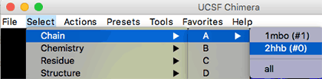

"**Chain A now has 2 options: one for each structure.**"

Now we can focus on the superimposed chains:

* **Select > Chain > A > 1mbo #1** to select myoglobin chain
* **Action > Focus** to zoom on the superimposed chains
* Ctrl-Click on the black background to unselect.

You can now rotate the structure and note where there are similarities and differences.

For example you may look for the conserved histidine coordinating the heme group, His 92 in 2hhb and His 93 in 1mbo.

### Model Panel: hide or show a structure

It may be useful to view each chain separately rather than as a superimposed composite. For this we will use the Model Panel to turn on or off the display of molecules. The Model Panel can be activated from the menu cascade **Tools > General Controls > Model Panel** or simply from **Favorites > Model Panel**

**TASK**

**Display or hide molecules.**

* Open the Model Panel (see menu cascades above)
* To see a specific model unselect the other(s) under the Shown column

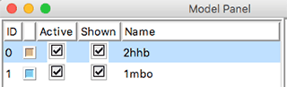

"**Show or hide structures independently.**"

### Compare sequences

In this exercise we will compare the sequences of the superimposed structures.

**TASK**

**Compare aligned sequences**

* **Tools > Structure Comparison > Match -> Align** will open the Create Alignment from Superimposition control panel.
* Select the chains that are aligned: chain the default chain A to all structures to the alignment that was performed above:
  + 2hhb (#0) chain D
  + 1mbo (#1) chain A
* Click OK

The alignment will be shown:

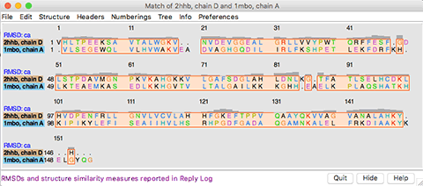

"**Aligned sequences.**"

Can you spot the conserved H histidines? [_] Yes [_] No

Can you spot other conserved, identical residues ? You can write their name/number ________________________

**TASK**

**Compute % identity**

We can compute a "percent identity" with the menu contained within the matched sequence panels:

* **Info > Percent identity...**  will open the Compute Percent Identities control panel
* use the pull-down options to select by changing all sequences to the desired chain. For example:
  + Compare: 2hhb, chain D
  + with: 1mbo, chain A`
* Click OK - the % identity will appear at the bootom of the sequence alignment window as 24.66%.

What value did you get? _________________________

# Favorites

We have explored the Favorites options execept Command Line

The command line options will be explored in a separate workshop.

However, you can learn here a very simple and useful command to alter the background color. The default color is black, in this exercise we will change it to white.

**TASK**

**Change background color by line command**

* **Favorites > Command Line** will open the command line at the bottom of the 3D view panel.
* type the following in the command line: set bg_color white and the background will change accordingly.
* You can reverse to black with set bg_color black
* Other colors are also possible: see preferences options from the panel discussed below.

# Preferences

There are many settings that can be changed on the fly, but also some that can be set as preferences.

The **Favorites > Preferences** control panel allows to change many settings that may become permanent in the Chimera installation.

## Font size

This is mentioned here as there is one change that we alluded before for the label font size. This is the place where many aspects of labels can be changed.

**TASK**

**Change label size**

* **Favorites > Preferences**
* Change the Category pull-down menu to Labels
* Change the font size from the default 16 to *e.g.* 36

# Acknowledgments

From the [UCSF Chimera](http://www.cgl.ucsf.edu/chimera) web site:

*UCSF Chimera is a highly extensible program for interactive visualization and analysis of molecular structures and related data, including density maps, supramolecular assemblies, sequence alignments, docking results, trajectories, and conformational ensembles. High-quality images and animations can be generated. Chimera includes complete documentation and several tutorials, and can be downloaded free of charge for academic, government, nonprofit, and personal use. Chimera is developed by the Resource for Biocomputing, Visualization, and Informatics (RBVI), funded by the National Institutes of Health (NIGMS P41-GM103311).*

[*UCSF ChimeraX*](https://www.cgl.ucsf.edu/chimerax/) *(or simply ChimeraX) is the next-generation molecular visualization program from the RBVI, following UCSF Chimera.*

# REFERENCES

Fermi, G., M. F. Perutz, B. Shaanan, and R. Fourme. 1984. “The crystal structure of human deoxyhaemoglobin at 1.74 A resolution.” *J. Mol. Biol.* 175 (2): 159–74.

Pettersen, E. F., T. D. Goddard, C. C. Huang, G. S. Couch, D. M. Greenblatt, E. C. Meng, and T. E. Ferrin. 2004. “UCSF Chimera–a visualization system for exploratory research and analysis.” *J Comput Chem* 25 (13): 1605–12. <http://www.cgl.ucsf.edu/chimera>.

Phillips, S. E. 1980. “Structure and refinement of oxymyoglobin at 1.6 A resolution.” *J. Mol. Biol.* 142 (4): 531–54.

1. <https://www.youtube.com/user/RCSBProteinDataBank>
2. <http://goo.gl/Ga0nr1>
3. <https://www.cgl.ucsf.edu/chimera/docs/ContributedSoftware/coulombic/coulombic.html>