DNASTAR RNASEQ TEMPLATED
Jean-Yves Sgro
February 21, 2017
Table of Contents

Acknowledgement
This tutorial is based on the Templated RNA-Seq Workflow on the DNASTAR Tutorial web page.
The tutorial is called "templated" as sequence reads are aligned to the genome template.
Note: A separate tutorial exists for cases where there is no template genome.

Introduction
Templated RNA-Seq uses next-gen sequencing to show the presence of RNA at a particular moment. RNA can be indentified and quantified by alignment to the genome.
This tutorial is meant to become familiar with the DNASTAR software for next-gen sequencing. In this tutorial we will use two DNASTAR software:
- SeqMan NGen will be used to align RNA-Seq data onto the genome.
- ArrayStar will be used tp analyse the completed RNA-Seq alignment assembly.
Note: While SeqMan NGen exists for both Mac and Windows, ArrayStar is a Windows-only software (as it is based on the Microsoft .Net framework.)

This Tutorial
In this tutorial, we will compare stationary phase RNA from wild-type Listeria monocytogenes cells with that from mutant cells that do not express sigma B, a major transcriptional regulator (see Oliver et al. (2009) and Appendix below.)
The tutorial is split in two parts following the software used:
- Part A: Setting up and running a templated RNA-Seq project in SeqMan NGen
- Part B: Analyzing the RNA-Seq results in ArrayStar
Choose which OS you prefer to work in. However, note that Part B can only be run within Windows and the file(s) from Part A would need to be transferred on the Windows side unless there is a way to share a directory.
For this tutorial it is therefore advised to run both Parts A and B under Windows.

Set-up

Lasergene DNASTAR
For this tutorial we need access to the DNASTAR software which is installed on the class iMacs.
- If you need to install the software on your lab or laptop computer follow instructions on the Biochemistry department web page for "Available Software" or open a Biochem IT job request on the Job Board.
- If you are within the Biochemistry department with a wired computer such as the iMacs in the classroom you can simply launch the software to use SeqMan NGen or ArrayStar.
- If you are on a wireless computer you will need to connect to the Biochemistry network by VPN

Download Data
The data for the workshop can be found on the DNASTAR Tutorial web page as T3_Templated_RNA-Seq.zip
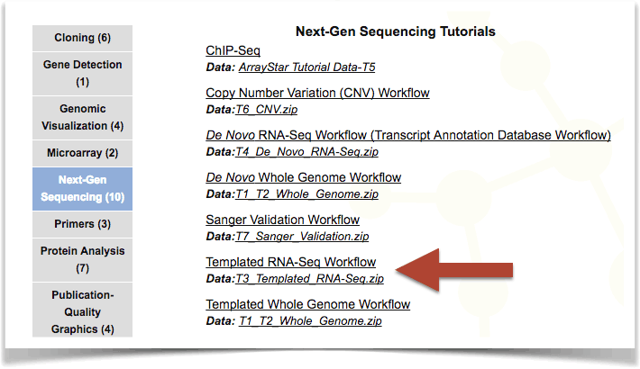
"Finding T3_Templated_RNA-Seq.zip on DNASTAR Tutorial web page"
$⨀$ TASK: Dowload the data to your desktop and unzip it.
The resulting directory will contain 5 files:
Listeria monocytogenes 4b F2365.NC_002973.6.gbk
sigB_1.fastq
sigB_2.fastq
wt_1.fastq
wt_2.fastq
- The .gbk file is a GeneBank sequence file for the complete genome of the bacteria Listeria monocytogenes.
- The fastq files are sequencing reads. There are two replicates each for the wild type (wt) and for an isogenic strain lacking Sigma B. (See also Appendix A below.)

Part A: Setting up a templated RNA-Seq project in SeqMan NGen

Launch SeqMan NGen
On both Mac and Windows you can launch individual DNASTAR software by finding them on the hard drive or for example the "Start" menu under Windows.
However, the DNASTAR Navigator consolidates all DNASTAR software in one place and may make it easier to launch any of the desired software.
SeqMan NGen is located under Genomics within the Navigator.
Click on SeqMan NGen to launch.

Macintosh
Perhaps the easiest way would be to use "Spotlight Search" (top right "magnifying glass icon") and start typing the name of the software. For SeqMan NGen it should appear after the first few letters are typed.
However, for this tutorial it is recommended to use Windows since the second part of the tutorial requires a Windows-only software.

Windows
Click on the "Start" button (bottom left - looks like a 4 white squares) and scroll down to the letter D where DNASTAR should be listed.
Click on the downward pointing arrow on the right hand side of the name and find the software you need. e.g. DNASTAR Navigator 14 or directly SeqMan NGen.

Choose where to work
The first screen after the launch offers 3 choices:
- Assemble on local computer
- Re-run local assembly
- Assemble on the DNASTAR cloud
$⨀$ TASK: Click Assemble on local computer.
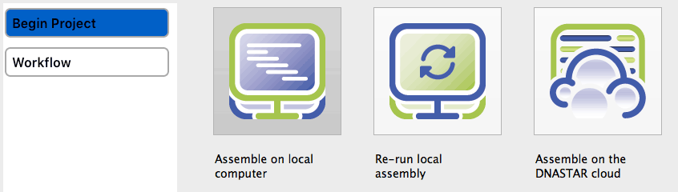
"Three choices on first screen**"

Choose workflow
On the next screen "Choose Assembly Workflow"" screen, select Transcriptome / RNA-Seq and press Next.
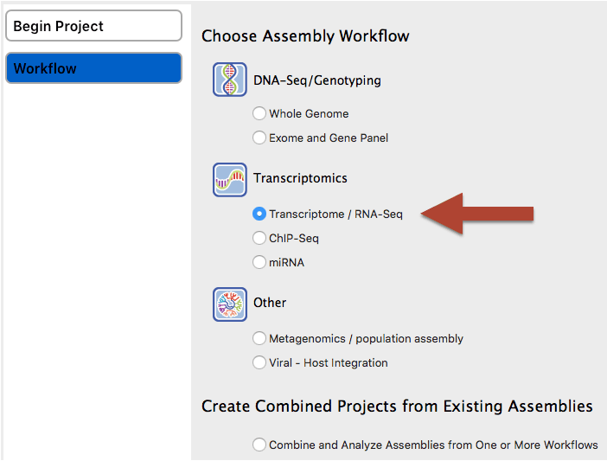
"select Transcriptome / RNA-Seq"

Choose Assembly Type
In the "Choose Assembly Type"" screen, select Reference based assembly and click Next.
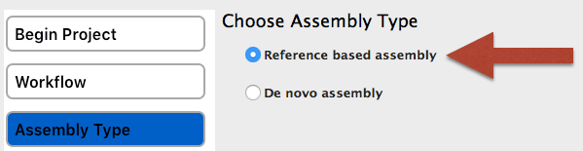
"select Reference based assembly"

Reference genome
- In the Input Reference Sequences screen add the reference sequence Listeria monocytogenes 4b F2365.NC_002973.6.gbk by pressing the Add button.
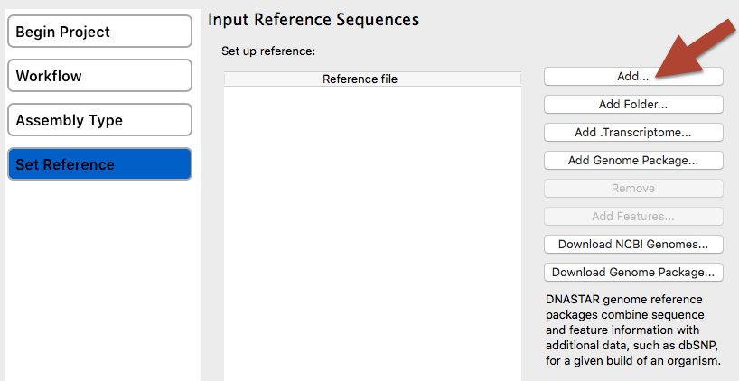
"Press Add and select reference sequence."
- Then select the file and click Open.
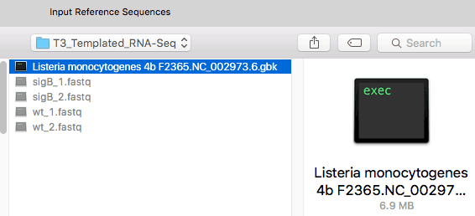
"Select file and click Open."
- Click Next
Note: If a reference sequence had not been provided with the tutorial data, you could have downloaded an L. monocytogenes genome here using the Download NCBI Genomes button.

Input Sequence Files and Define Experiments
In the Input Sequence Files and Define Experiments or Individual Replicates screen: (See illustration below.)
- Set the Read technology to Illumina, and uncheck the paired-end data box.
- Check the Run Multi-sample data as separate assemblies box.
- Check the Samples have replicates box. When you do so, note that the "Experiment" column header below has changed to "Individual Replicate."”"
- Using the procedure described in the previous step, use the Add button to add all four .fastq files from the tutorial data folder.
- Name each of the four files by clicking on "ENTER NAME" and type in the name sigB_1, sigB_2, wt_1 or wt_2, as appropriate for that row.
- Click Next.
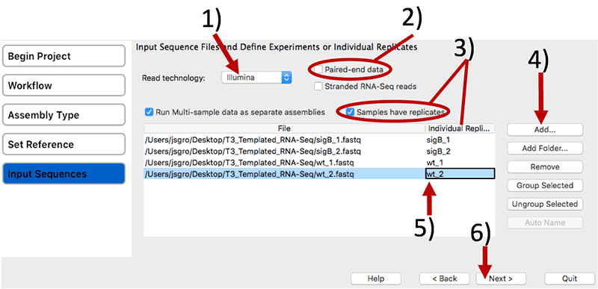
"Follow all steps to set-up files and define experimental details."

Group replicates
In the Group Individual Replicates into Replicate Sets screen:
- Select the two sigB replicates and click on the Group Selected button. In the dialog, name the set sigB and click OK.
- Do the same for the two wt replicates, naming the set “wt.”
- Click Next.
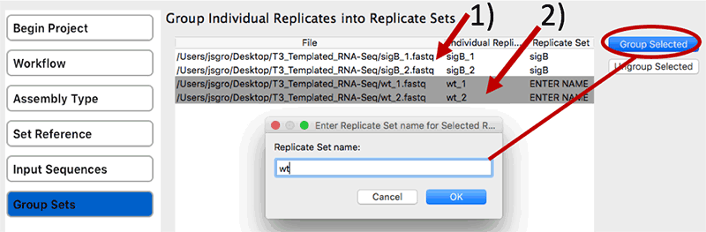
"Group replicates to define experiment."

Choose control
In the Set Up Experiments screen, check the Is Control box to the right of wt. Then click Next.
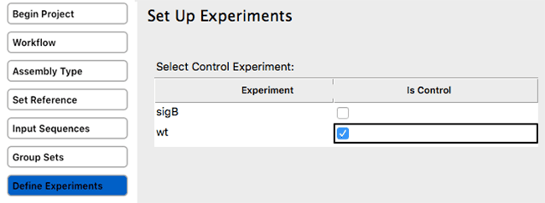
"Group replicates to define experiment."

Set Assembly options
In the Assembly Options screen, check Haploid (since this is a bacterial genome)
There is nothing else to change on that screen.
Then click Next.
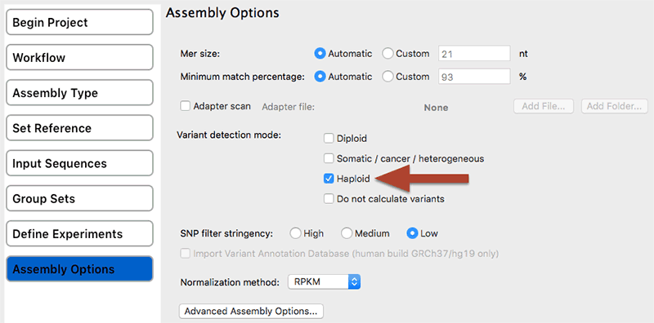
"Assembly options: check Haploid."

Assembly output
In the Assembly Output screen:
- Type "Templated RNA-Seq" into the Project Name text box. This name will be assigned to all output files, including the finished assembly.
- Use the Browse button to specify a Project Folder for your assembly output files. Note: For local users, an alternative way to select a location is to drag and drop a folder from the file explorer onto the Project Folder row.
- Click Next.
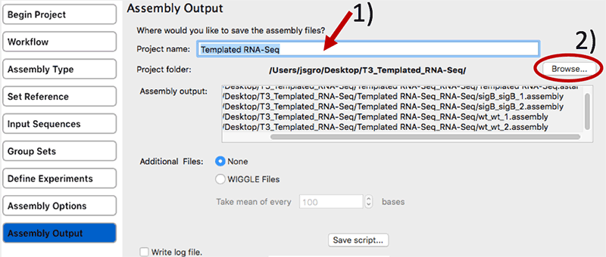
"Assembly options: check Haploid."

Start Assembly
In the "Your assembly is ready to begin" screen is revealed the script created by our previous clicks. However, all you have to do is press Start Assembly to begin the assembly.
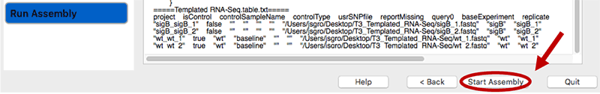
"Start Assembly."
Assembly will be complete within about 5 minutes depending on hardware configuration.

Finish Assembly
Wait until being informed that assembly has finished, then click Next.
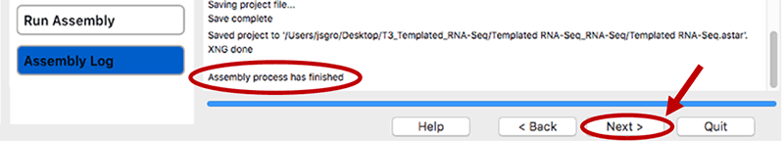
"Finish Assembly."

Save Project
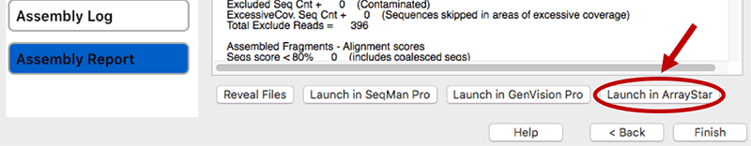
"Finish Assembly."
If you are on a Windows system the ArrayStar software will launch. See part B for continuing the analysis.
If you are on a Macintosh the transfer will not work and a warning message will appear:
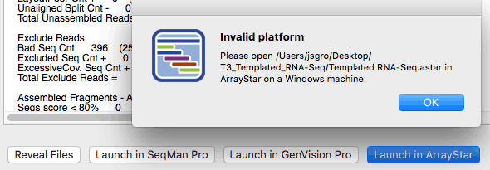
"Finish Assembly."
Note: The file Templated RNA-Seq.astar can be transfered on the Windows side to continue the analysis.

Part B: Analyzing the RNA-Seq results in ArrayStar.
In Part B, we will analyze the results of the RNA-Seq assembly in ArrayStar by using a "quick gene set" to locate a potential operon structure.
An "operon" is a group of one or more genes that are transcribed as a single RNA unit.
In this section of the tutorial, we will create a "quick gene set," then use the Gene Table to search for potential operon structures.

Launch ArrayStar
Either use the DNASTAR Navigator opened earlier (ArrayStar is listed under the Genomics category,) or find ArrayStar within the Windows "Start" menu on the bottom left (see beginning of tutorial above.)
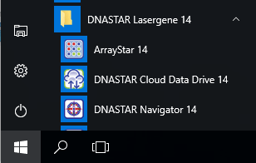
"Use the 'Start' button to launch ArrayStar."

Get Started
When we ran SeqMan NGen we saved a file called Templated RNA-Seq.astar which will serve as the start for the analysis. This file is compiled as a "project" and therefore:
Within the first panel in ArrayStar under Get Started choose Open a project... and navigate to where the file was saved (probably within a directory called "Templated RNA-Seq_RNA-Seq")
Note: In order to be [allegedly] "helpful" Windows will hide know filename extensions. Therefore your file will appear without the .astar extension, which can be confusing.
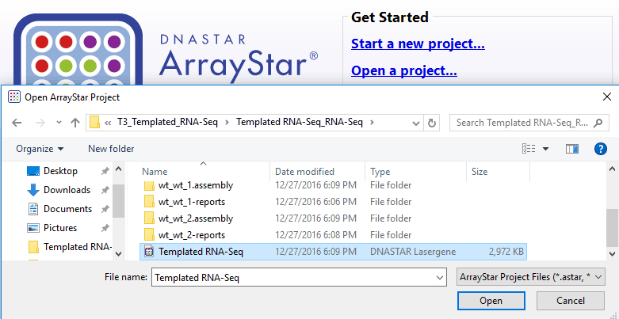
"Open project file Templated RNA-Seq.astar."
Click Open
Note: It will take about 30 seconds to 1 minute to load and display the data under the "Scatter Plot" tab.

Organize data
Before continuing any further click on the "Experiment List" tab
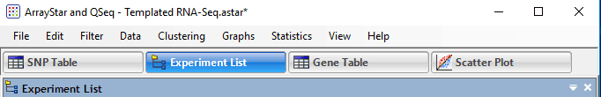
"Click on the "Experiment List" tab."
Depending on how the data was loaded into ArrayStar, you will see either an RNA-Seq folder or both an RNA-Seq and Variant folder. In the latter case, select the Variant folder, then right-click on it and choose Delete. When prompted, press the Delete button.
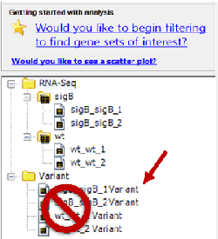
"Right Click on folder "Variant" to delete it."
You will be warned with: "Are you sure you wish to delete 4 experiments? You will not be able to undo this deletion."
The variant analysis is used as part of another DNASTAR tutorial and it is safe to remove these for our purpose: Click the Delete button.

Quick Gene Set
To access the Quick Gene Set Creation dialog, use the menu command Graphs > Venn Diagrams and then press the Quick gene set creation button.
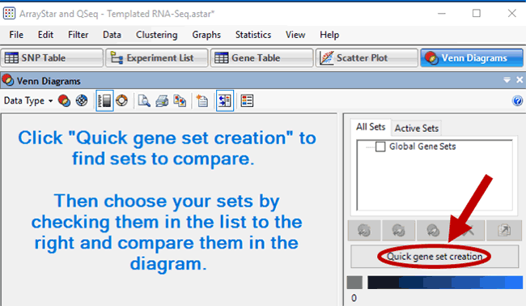
"Menu: Graphs > Venn Diagrams then click Quick gene set creation."
This will open the "Step 1" comparison workflow window options and in the next section we will chose one.

Step 1- choose one comparison workflow
The window panel offers 3 different methods to compare and the experimental material:
- Check expriments individually
- Compare experiments to a baseline (we will choose this one below)
- Compare all experiments pairwise
In the center section of Step 1, Compare Experiments to a Baseline, select a Baseline Experiment of wt, and then click the Select button just below.
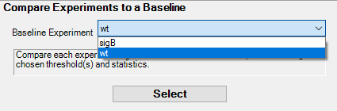
"Choose wt as the baseline."

Step 2- Select experiments and genes to compare
Keep everything as the presented default: click button Move to Step 3 (Comparisons).

Step 3
In Step 3, keep the Signal Threshold and Fold Change boxes checked, but uncheck the P value box.
Also remove the checkmark by the Up box, to the right of Fold Change.
The filter is now set up to find genes in the sigB mutant samples that have a >= 2-fold downward change, compared to the wildtype, and an RPKM signal value >= 10.
Press Finish.
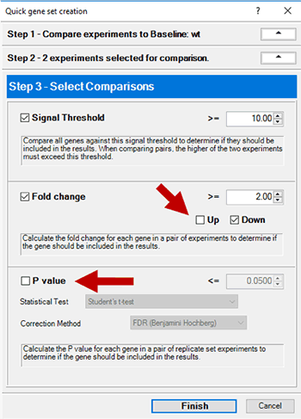
"Uncheck P value and Up as marked."

Set List
Open the Set List by using the menu cascade Data > Show Set List. Note that the newly-created quick gene set is already selected and called sigBxwt, 2 fold down, signal>=10.
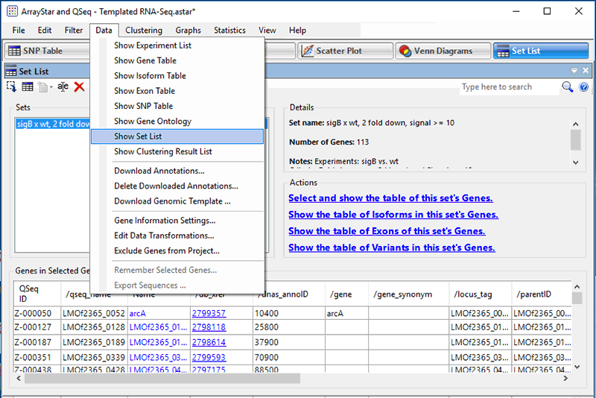
"Menu cascade Data > Show Set List."

Show gene table
DNASTAR software makes heavy use of icons that may not have menu items equivallents.
Such is the region of the ArrayStar panel called "Actions section" (see illustration below.)
In the Actions section, click the link Select and show the table of this set’s Genes (2nd icon from the left as illustrated below.)
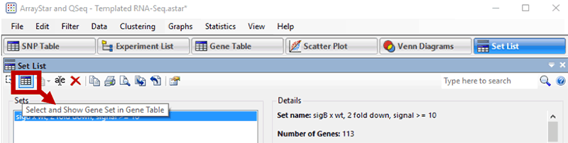
"Use the second button on the Actions section."
While only three columns appear initially, the Gene Table can display a variety of gene name and annotation fields, notes, expression levels, and statistical calculations.
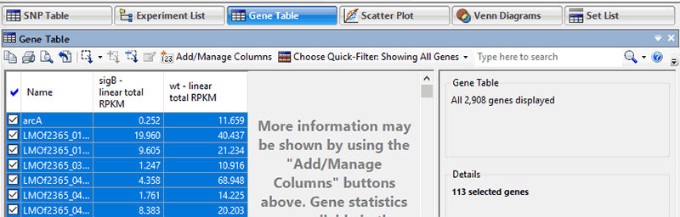
"Resulting Gene Table is first shown with only 3 columns."
We will add some columns in the next section.

Add information columns
On the Actions section of icons click the Add/Manage Columns tool () to open the Manage Columns dialog.
- Under Available Gene Info, select Target Range. Press the > Add Column > button to add the items to the Current Columns list.
- Click the Gene Values button. Then select Signal. Click the Log2 radio button, then press > Add 2 Columns > to add them to the Current Columns list.
- Click OK to close the Manage Columns dialog and return to the Gene Table.
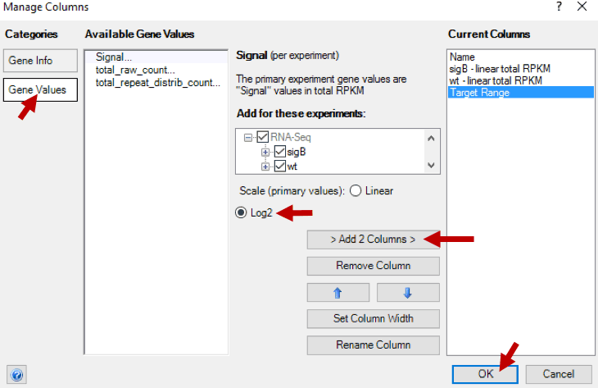
"Add/Manage Columns. Step to add Log2 values."

Fold Change
On the same line of icons click the Add Fold Change tool (.)
Specify a Control of wt and an Experiment of sigB, then press OK.
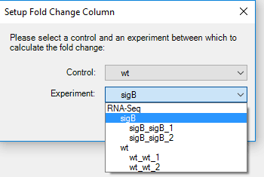
"Specify control and experiment samples"
The Gene Table should now contain seven columns.
Due to the choice made above all fold changes show a down direction.

Sort genes
Click once on the column header for Target Range to sort all of the genes in the project in ascending order of appearance on the assembly.
Scroll down, noting that the genes within the "quick gene set" remain selected in blue and are interspersed along the whole table as illustrated below.
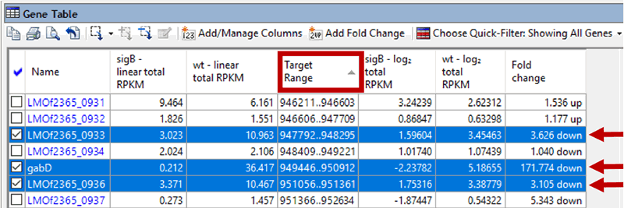
"Genes within the "quick gene set" remain selected in blue (arrows.)"

Show selected genes
To remove genes that are not in the "quick gene set" from the table, click on the Choose Quick-Filter tool ( and select Show Only Selected Genes.
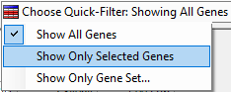
"Show only the "quick gene set" in the table."

Unselect genes
- Click on any row to select it.
- Then Ctrl+click (This could be SHIFT+Ctrl+click on a Mac running Windows) the same row to remove the selection from that row.
- The table should now contain no blue highlighting.

Identify possible operon structures
To identify possible operon structures, scroll down the Gene Table, noting sections where consecutive, or nearly consecutive, genes show similar trends in expression levels and fold changes. One candidate for an operon would be the four overlapping (or adjacent, in one case) genes starting with LMOf2365_0912 and ending with LMOf2365_0915.
This also happens to be the location of the sigB gene (arrow) :
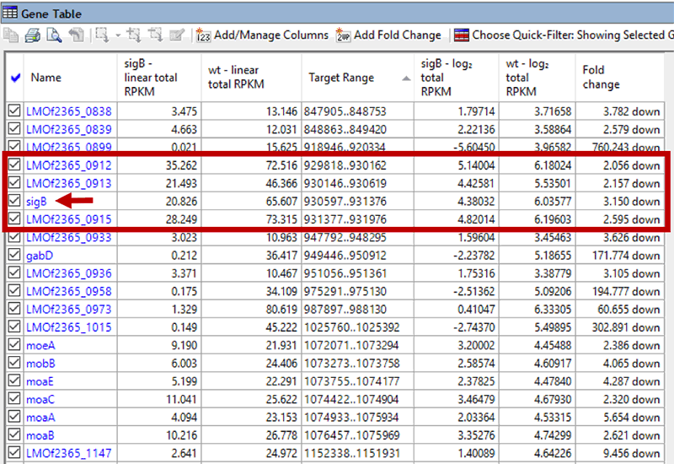
"Potential operon structures."

More potential operons
Check the list, you may find more, for example:

molybdo-cofactor biosynthesis genes
moeA 9.190 21.931 1072071..1073294 3.20002 4.45488 2.386 down
mobB 6.003 24.406 1073273..1073758 2.58574 4.60917 4.065 down
moaE 5.199 22.291 1073755..1074177 2.37825 4.47840 4.287 down
moaC 11.041 25.622 1074422..1074904 3.46479 4.67930 2.320 down
moaA 4.094 23.153 1074933..1075934 2.03364 4.53315 5.654 down
moaB 10.216 26.778 1076457..1075969 3.35276 4.74299 2.621 down
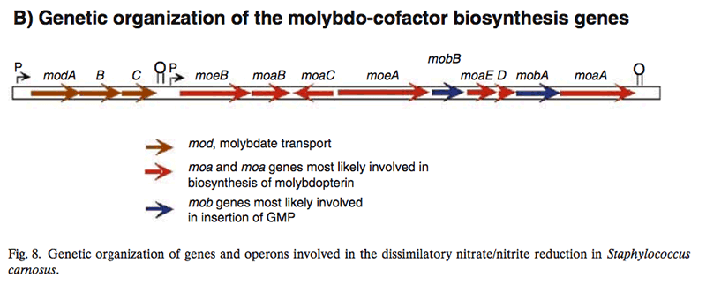
"Figure 8 from Dworkin M., Falkow S., Rosenberg E., Schleifer K.-E., Stackebrandt E. (2006). Molybdo-cofactor biosynthesis genes."
From Dworkin M., Falkow S., Rosenberg E., Schleifer K.-E., Stackebrandt E. (2006): Molybdopterin Cofactor Biosynthesis.
In S. carnosus, nine genes were identified (Fig. 8), all of which appear to be involved in molybdenum cofactor biosynthesis
(Note: As of this writing, the book PDF can be downloaded from the Springer web site http://link.springer.com/referencework/10.1007%2F0-387-30744-3 )

opuC
opuCD 9.620 28.024 1437146..1436475 3.26596 4.80862 2.913 down
opuCC 4.612 17.954 1438087..1437161 2.20553 4.16620 3.892 down
opuCB 7.037 15.689 1438745..1438089 2.81504 3.97171 2.229 down
opuCA 7.067 19.397 1439942..1438749 2.82103 4.27777 2.744 down
The operon, designated opuC, consists of four genes which are predicted to encode an ATP binding protein (OpuCA), an extracellular substrate binding protein (OpuCC), and two membrane-associated proteins presumed to form the permease (OpuCB and OpuCD). The operon is preceded by a potential SigB-dependent promoter. (Fraser et al. 2000)

Appendix

Appendix A: Data
The data used in the tutorial was published in (Oliver et al. 2009) and is available for download on the Gene Expression Omnibus (GEO) under accession number GSE15651
Oliver et al. (2009) info:
Experiment type
Expression profiling by high throughput sequencing
Summary
The stationary phase stress response transcriptome of the human bacterial pathogen Listeria monocytogenes was defined using RNA sequencing (RNA-Seq) with the Illumina Genome Analyzer. Specifically, bacterial transcriptomes were compared between stationary phase cells of L. monocytogenes 10403S and an otherwise isogenic DsigB mutant, which does not express the alternative sigma factor sigma B, a major regulator of genes contributing to stress response.
Keywords
Transcriptome and differential expression analyses
Overall design
a laboratory strain, 10403S and its otherwise isogenic mutant lacking sigB were analyzed. Two replicates of each strain were analyzed for a total of 4 runs
The four sample files have been renamed on the DNASTAR web site. The names on the GEO site are labeled as:
File Name | Replicate name
GSM391674 | 10403S_replicate1
GSM391675 | DsigB_replicate1
GSM391676 | 10403S_replicate2
GSM391677 | DsigB_replicate2

Appendix B: SigmaB
SigmaB definition (Raengpradub, Wiedmann, and Boor 2008)
A sigma factor is a dissociable protein subunit that directs bacterial RNA polymerase holoenzyme to recognize a promoter sequence upstream of a gene prior to transcription initiation. New associations between alternative sigma factors and core RNA polymerase essentially reprogram promoter recognition specificities of the enzyme in response to changing environmental conditions, thus allowing expression of new sets of target genes appropriate for the conditions.
Sigma B modulates the stress response (Schaik and Abee 2005)
The alternative sigma factor sigmaB modulates the stress response of several Gram-positive bacteria, including Bacillus subtilis and the food-borne human pathogens Bacillus cereus, Listeria monocytogenes and Staphylococcus aureus. In all these bacteria, sigmaB is responsible for the transcription of genes that can confer stress resistance to the vegetative cell.
The question as to what extent and under which conditions sigmaB is responsible for survival during stress has been addressed by phenotypic characterization of sigB deletion mutants.
These studies revealed that sigmaB is involved in the resistance to a variety of stresses including heat, high osmolarity, high ethanol concentrations, high and low pH, and oxidizing agents [...]. In L. monocytogenes and B. subtilis, sigmaB was shown to have a role in growth and survival under low temperatures [...].

Appendix C: Sigma B Operon
In L. monocytogenes, 168 genes were positively regulated by sigmaB; 145 of these genes were preceded by a putative sigmaB consensus promoter (Raengpradub, Wiedmann, and Boor 2008.)
The genes positively regulated by sigmaB were classified into nine functional categories:
- Stress
- Virulence and virulence associated
- Transcriptional regulation
- Transport and transport systems
- Metabolism
- DNA metabolism and transport
- Protein synthesis and modification
- Cell envelope and cellular processes
- Unknown and hypothetical

Appendix D: Listeria monocytogenes
L. monocytogenes is a non-spore-forming facultative intracellular pathogen that causes listeriosis, a serious invasive disease in both animals and humans. To establish a food-borne bacterial infection, L. monocytogenes must have the ability to survive under a variety of stress conditions, including those encountered in a wide range of nonhost environments and food matrices, as well as under rapidly changing conditions encountered during gastrointestinal passage (exposure to organic acids, bile salts, and osmotic gradients) and subsequent stages of infection (e.g., in the intracellular environment). L. monocytogenes sigmaB is activated following exposure to a number of environmental stress conditions [...] and contributes to bacterial survival under acid and oxidative stresses and during carbon starvation [...] (Raengpradub, Wiedmann, and Boor 2008.)

Resources
- A survey of best practices for RNA-seq data analysis Conesa et al. (2016a), Conesa et al. (2016b)
- RNA-seq Analysis Workshop Course Materials
- RNA-seqlopedia
- Standards, Guidelines and Best Practices for RNA-Seq V1.0 (June 2011) The ENCODE Consortium
- Guidelines for RNA-Seq data analysis (prot 67)

REFERENCES
Conesa, A., P. Madrigal, S. Tarazona, D. Gomez-Cabrero, A. Cervera, A. McPherson, M. W. Szcze?niak, et al. 2016a. “A survey of best practices for RNA-seq data analysis.” Genome Biol. 17 (January): 13. https://www.ncbi.nlm.nih.gov/pubmed/26813401.
———. 2016b. “Erratum to: A survey of best practices for RNA-seq data analysis.” Genome Biol. 17 (1): 181. https://www.ncbi.nlm.nih.gov/pubmed/27565134.
Dworkin M., Falkow S., Rosenberg E., Schleifer K.-E., Stackebrandt E., ed. 2006. The Prokaryotes A Handbook on the Biology of Bacteria. 3rd ed. Vol. 4. Bacteria: Firmicutes, Cyanobacteria. New York NY: Springer. http://link.springer.com/referencework/10.1007%2F0-387-30744-3.
Fraser, K. R., D. Harvie, P. J. Coote, and C. P. O’Byrne. 2000. “Identification and characterization of an ATP binding cassette L-carnitine transporter in Listeria monocytogenes.” Appl. Environ. Microbiol. 66 (11): 4696–4704. https://www.ncbi.nlm.nih.gov/pmc/articles/PMC92368/.
Oliver, H. F., R. H. Orsi, L. Ponnala, U. Keich, W. Wang, Q. Sun, S. W. Cartinhour, M. J. Filiatrault, M. Wiedmann, and K. J. Boor. 2009. “Deep RNA sequencing of L. monocytogenes reveals overlapping and extensive stationary phase and sigma B-dependent transcriptomes, including multiple highly transcribed noncoding RNAs.” BMC Genomics 10 (December): 641. http://www.ncbi.nlm.nih.gov/pubmed/11581570.
Raengpradub, S., M. Wiedmann, and K. J. Boor. 2008. “Comparative analysis of the sigma B-dependent stress responses in Listeria monocytogenes and Listeria innocua strains exposed to selected stress conditions.” Appl. Environ. Microbiol. 74 (1): 158–71. https://www.ncbi.nlm.nih.gov/pubmed/18024685.
Schaik, W. van, and T. Abee. 2005. “The role of sigmaB in the stress response of Gram-positive bacteria – targets for food preservation and safety.” Curr. Opin. Biotechnol. 16 (2): 218–24. https://www.ncbi.nlm.nih.gov/pubmed/15831390.

http://www.dnastar.com/t-support-tutorials.aspx#/seqman_ngen_tutorials/#!Documents/tutorial3templatedrnaseqworkflow.htm
http://www.dnastar.com/t-support-tutorials.aspx
https://biochem.wisc.edu/intranet/it/available-software
http://vpn.wisc.edu/
https://s3.amazonaws.com/star-deploy/SupportingDataFiles/LG14/SeqMan+NGen+Tutorial+Data/T3_Templated_RNA-Seq.zip
https://www.ncbi.nlm.nih.gov/geo/query/acc.cgi?acc=GSE15651
https://genomebiology.biomedcentral.com/articles/10.1186/s13059-016-0881-8
http://chagall.med.cornell.edu/RNASEQcourse/
http://rnaseq.uoregon.edu/
https://genome.ucsc.edu/ENCODE/protocols/dataStandards/ENCODE_RNAseq_Standards_V1.0.pdf
http://www.epigenesys.eu/en/protocols/bio-informatics/1283-guidelines-for-rna-seq-data-analysis

